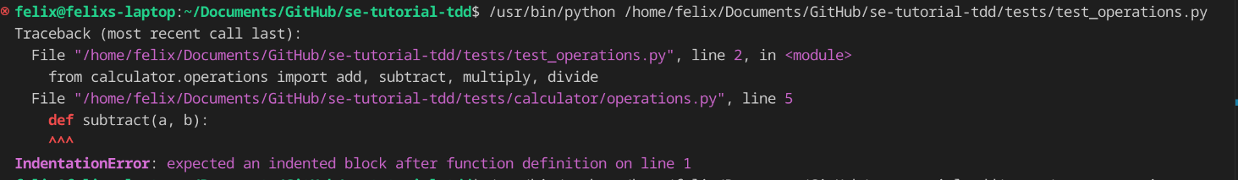

add

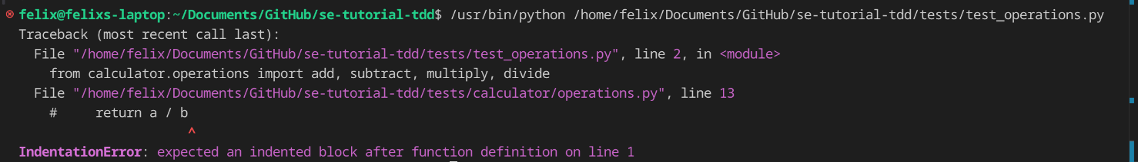

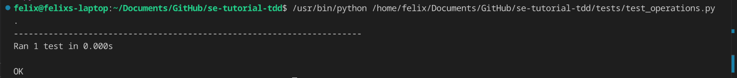

subtract

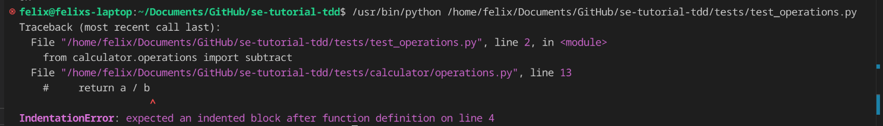

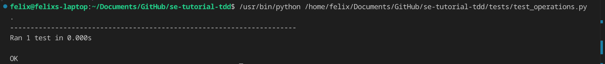

multiply

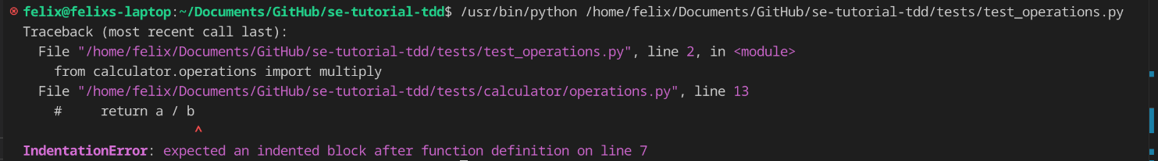

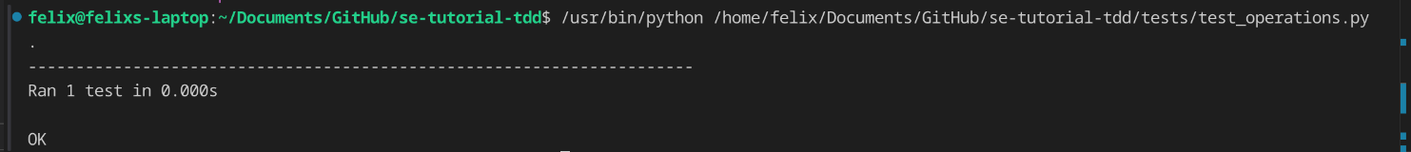

divide

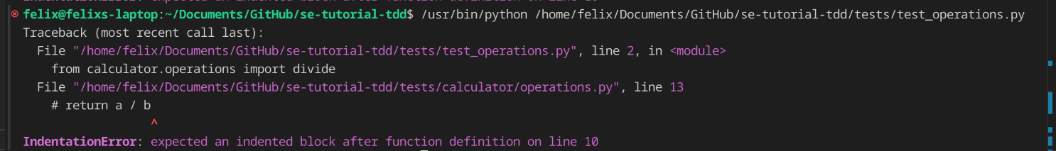

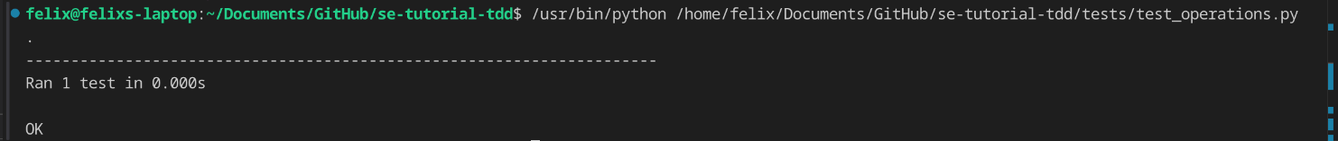

all code

